**Expect Engagement: Towards an Interdisciplinary Curriculum**

**Abstract**

Sir Michael Wilshaw, the chief of OFSTED in the UK, has recently declared that the British education system is failing poor children. Wilshaw identifies a lack of engagement with education as a problem which leads children to leave education at the earliest possible moment. This paper explores how a reformed national curriculum in the United Kingdom could enhance engagement and improve teaching and learning. It sets out to draw together evidence which makes a case for an interdisciplinary curriculum. The benefits and limitations of implementing this at key stage-three are discussed, and proposals for a rotation and research at key stage-four are also discussed.

**Article**

This paper sets out ideas for improving the national curriculum at key stages three and four (11-16) for the benefit of students in state education in the United Kingdom. Discussed in this paper are:

* An emphasis on fully interdisciplinary teaching at key stage-three
* Specialised teaching within subject areas at key stage-four
* A research-based qualification at level 2

**Context and Influence**

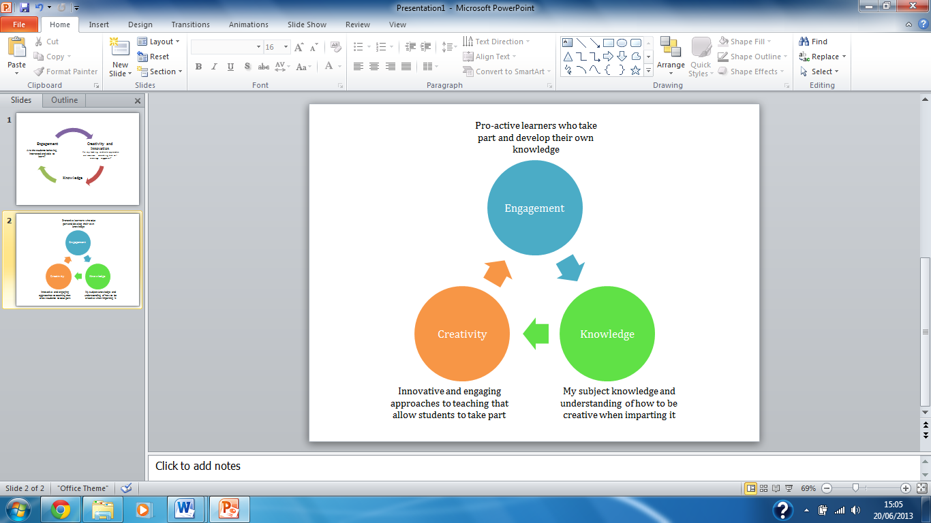The work is underpinned by secondary research and primary experience. I worked as an unqualified teacher of English and media studies in a secondary state school in Sunderland for two years and found it to be a formative experience: many of the views shared here are based on this experience. I also undertook a three month film pedagogy action-research project in the same school. The school is in a deprived area of Sunderland and accommodates around 1,000 students regardless of sex, race and religion, though the vast majority are white working class. The school is also a failing one: having previously been judged to be Good under the previous OFSTED framework, the school is now Satisfactory (now referred to as Requires Improvement) and expecting to be branded Inadequate and put into special measures in the near future. Only five of its staff (one manager, three teachers, and one instructor) were graded Outstanding for their teaching and learning during the last inspection; two of these staff members have since left the school and education in general. While internal inspections found most staff to be Requires Improvement under the most recent OFSTED framework, my own teaching (experience/repertise??) was Good. At the heart of my teaching I placed three key principles required for successful pedagogy which shape the rest of this paper:

**Definition**

Interdisciplinary teaching does not refer to ‘cross-curricular links’ which already exist in education. Rather than having cross-curricular numeracy on a science lesson plan for a teaching session in which maths plays a small part, interdisciplinary teaching and learning refers to a lesson which is specifically designed to deliver two subjects within the same teaching time by covering shared ground. To use the same example, mathematics could be taught within a science lesson but the emphasis would be equally shared. Elsewhere, history might be taught within English lessons, with students studying the poetry of the First World War through an in-depth look at the context of production. This concept could be explained to the public easily, as thus: two lessons are taught within the space of one timetabled lesson slot. Students benefit from meeting the learning outcomes of two subject areas within one school period, and are more engaged in doing so.

**Key Stage Three**

My proposed idea is that all teaching at key stage three is delivered in this way. This cannot be achieved in the same way at key stage four due to optional subject choices and specific exam content, thus key stage four is discussed later. Lois Kelly (2011) notes that this approach fits well with a constructivist view of education as it posits that “children work collaboratively and learn from their own direct experience” (p.5). Further to this, Carr (2007) and Kerry (2011) have both stated that merely recalling facts previously stated by the teacher is not learning. For knowledge to be gained the student must make a coherent whole from disparate findings, i.e. learning from indicating and discovering the points of contact between two subjects in a lesson with well-structured and well planned aims. On this topic, Edward Green (2011) has produced research which shows that single subject lessons invite teachers to plan vague intended learning outcomes and so students are unsure of what they should learn in that class. Interdisciplinary lessons would be less likely to invite this issue as the specific point of contact between the two subjects would frame clear and precise aims: Green (2011) noted that an online lesson plan asked students in a Citizenship class to understand crime in the local area in a lesson centred on knife crime. This led to a “lack of specific learning objectives, and engaging tasks.” (p.10) However, upon adapting the lesson plan to be interdisciplinary (including music as the second subject) the objectives became much more focused. Fautley and Savage (2011) produce similar research which Green draws upon to solidify his findings: “they state that the cross-curricular model often moves education away from teacher-led lessons and toward independent learning. They also make it clear that the practical end-product of the lesson does not constitute ‘learning’ but *evidence* of learning.” (p.5)

To frame the argument thus far with a different theoretical framework, consider it in relation to Bloom’s Taxonomy, as revised by David Krathwohl (2002) and Lorin Anderson (2002). The single subject lesson has been criticised for inviting students to only develop the low order thinking skills, such as basic recall. On the other hand, the interdisciplinary teaching requires analysis, rigour and creativity. While it is possible to have these skills present in single subject lessons, it appears that interdisciplinary teaching makes it much easier to achieve and evidence them. My own research shows this. In my paper *The Kids Are All Right: Reflections on Teaching with Film in British Secondary Education* (2013), I report the findings of a series of interdisciplinary lessons: Citizenship and media studies are the subjects present. Although this was not an investigation into interdisciplinary teaching, it did present results which are relevant. The lesson had distinct intended learning outcomes which were written specifically in the context of the teaching method: students would watch film clips related to drug abuse and answer questions relating to that clip before engaging in a class discussion. In response to these, the vast majority of the 200 key stage four students (of both sex, and all abilities) made progress; furthermore, the progress they made was achieved using high order thinking skills, such as creating, analysing and predicting. The lesson was also well balanced in being both about Citizenship and media studies, with objectives which related to both the social impact of drug abuse and the mental illnesses caused by substance abuse as well as issues of media representation and notions of the director as an auteur.

The benefits of my suggestion that the key stage three curriculum could be more engaging and productive by having interdisciplinary lessons with student-led tasks seem apparent: learners will develop high order thinking skills, they will be able to reflect upon their own learning experience and apply those skills elsewhere, and they will develop knowledge rather than simply recalling facts. However, this is speculative. To evidence this, I present the findings of Andrew Price (????), whose research into year 7 interdisciplinary education emphasises my point. He found that “there was an improvement in the quality of numerous areas of pupil learning, including: questioning, self and group reflection, sharing of ideas, consensus and awareness of task requirements” (p. ??) as well as a rise in participation, especially questioning and critically analysing others’ points, and becoming more aware of thinking skills and how to transfer them to other tasks. Once again, the evidence here is that interdisciplinary education encourages and develops opportunities for high order thinking skills and enhances engagement and reflection. This is something which can only be achieved through fully interdisciplinary teaching and not the aforementioned cross-curricular links as this lacks the “authentic” (p. 6) links between subjects that Kelly says is required to get the most out of the aims and objectives of the lesson. That is to say, if the lesson merges two subjects in a way which is not authentic, then the second subject becomes like an unnecessary extra: Phil Beadle (2010) shares this view and, while he emphasises the importance of cross-curricular literacy, he finds the notion of cross-curricular links to be impractical for this reason. For example, Beadle caricatures cross-curricular links by saying that introducing ICT skills to an English lesson, students are expected to use computer programmes to create timelines of Joseph Conrad’s life, leaving no time to read his novels.

**Limitations**

Interdisciplinary teaching and learning is not without limitations. Green’s (????) research uncovered that “often students would show a bias toward one or other of the subjects, and engagement in the other would suffer, however in general, there was a high level of engagement from students”(p.10). This could be seen as a limitation as the point of an interdisciplinary education is that the student gains knowledge in two subjects, but Green is identifying an issue with this: students choose which subject they will engage with. However, Green does note a high level of engagement overall, so if the objectives and tasks in the lesson require skills to be developed in both subjects then the student’s engagement with one interest will require them to develop the skills in the other. To return to the history and English war poetry examples, if a student enjoys poetry but is disengaged with history, the teacher could set the task of selecting evidence of shell shock in a poem: this would require the student to understand the historical and cultural understanding of shell shock around the time of the First World War, and the symptoms of it. There is a second benefit to being engaged however: OFSTED’s Sir Michael Wilshaw has described one of the reasons why the current education system is failing poorer children. He put it thusly: “they coast through education until – at the earliest opportunity – they sever their ties with it” (Adams, 2013). Wilshaw has identified students’ lack of engagement with education: the image of a child ‘coasting’ through their school years without engaging with learning is symptomatic of those lessons in which the objectives are vague and activities require only basic skills. The introduction of an engaging and creative interdisciplinary education is something which evidently can tackle this issue in key stage three.

There are two further potential areas for limitation which I will note briefly:

* Green notes that there would be large changes to policy and practice required in schools for interdisciplinary teaching and learning to be introduced. If introduced by government then this would not be such an issue. Green notes it as only being a limitation is a single school were to choose to adopt this approach.
* Teachers, likely to have degrees in single subjects, would be expected to teach a second subject. However, this is a minor issue for several reasons: teachers are likely to have gained knowledge of other subjects at A level; degree-level study encourages interdisciplinary perspectives, for example an English teacher would know of the historical context surrounding war poetry from their English degree and a physics graduate would have an advanced knowledge of mathematics; and, Continued Professional Development would provide an opportunity for subject enhancement. Further to this, teachers may also have joint honours degrees.

**Key Stage Four**

Interdisciplinary teaching and learning would not work at key stage four. This is because each subject would require specific teaching towards the exam content and require allocated time for the completion of controlled assessment tasks. Furthermore, students choose their optional (non-core) subjects at GCSE thus making it difficult, if not impossible, for a school to accommodate interdisciplinary teaching at key stage four when students at this level have such varying timetables. It could, however, have it in Citizenship lessons, and my research shows that this would be beneficial. Therefore, at key stage four, I would make two changes:

* Specialist Teaching within the Core Curriculum Areas

In order to engage students in the core curriculum areas, in which schools will have numerous teachers on their staff, I would propose that each member of staff specialises in one area of the exam topic. Over a period of weeks, the classes would revolve around each member of staff on a carousel and that teacher would deliver their specialised topic from the upcoming exam paper. Noel Stoddart (2011) finds: “this arrangement would mean that all teachers should be delivering outstanding, well differentiated lessons if they can concentrate on developing and delivering resources in a particular topic area”. The example below demonstrates how this could work for teaching GCSE English Literature over a term, but is obviously theoretical and not based on an actual school or exam board.

|  |  |  |  |  |
| --- | --- | --- | --- | --- |
| **Teacher of…** | Shakespeare | War Poetry | Pre-1914 Poetry | Post-1914 Novel |
| **Half term 1** | Class A | Class B | Class C | Class D |
| **Half term 2** | Class D | Class A | Class B | Class C |

From my own experience of teaching in this way, I have noted that students are more engaged. Having taught media in a timetabled subject called Creative Arts which was made up of media studies, dance and drama, I have observed how students become more engaged when they feel they are taught by a subject specialist. Other benefits include a variety of teaching and learning styles are offered to the students who would otherwise be in receipt of the same teaching style: the change in teacher meant that, if they were unable to engage with the previous teacher, a different delivery in the next half term would lessen the impact of being disengaged. To return to Wilshaw’s concern, it is better for a child to be disengaged for six weeks than for the full academic year. Ultimately my experience fully supports Stoddart’s view.

* Introduce a GCSE Research Qualification

At degree level study and A level study, students are able to research projects of their own interest. While this is more traditional and more common at degree level study, the Extended Project Qualification which is an AS level equivalent is the model upon which I would base a research-orientated GCSE. Such a qualification already exists: the Level 2 Higher Project. However, it is not compulsory and not widespread practice for schools to offer it as I would have it for the following reasons, but it is in practice and readily available.

Warren Kidd and Gerry Czerniawski (2011) note that research by students is an example of “best practice” which has “outstanding” results due to “the quality of and depth of learner engagement and involvement [and] the skills they develop” (p. 169). AQA, a qualification body which awards the qualification, states that the aim of the research is to allow students to benefit from independent inquiry, become engaged through choice of study and develop career or future study ambitions. If the qualification is made compulsory, then all students would benefit from the highest order of thinking skills and would have regular opportunities to reflect upon their own learning and the skills they have developed. The final output of some kind of report would qualify the student in the highest order thinking skills on Bloom’s Taxonomy: using new knowledge to create.

**Summary**

To return to my three key principles, the above has outlined a new approach to delivering the national curriculum to benefit the students that OFSTED have suggested suffer due to lack of engagement. Engagement, Creativity and Knowledge all play a central role in my plans, with teachers delivering a creative and engaging curriculum at key stage three which emphasises the development of skills in an interdisciplinary setting. At key stage four, teachers’ specialist knowledge is used to the same purpose but more practically, taking exams and students’ options into consideration. This is put to good use through the introduction of a carousel timetable which has been proven effective and a research qualification which will bring about engagement and outstanding results. Overall, in applying these principles and bringing together recent research, I have demonstrated how the disengaged children failed by the education system could benefit from an interdisciplinary education.

**Bibliography**

Adams, R. (2013) *Schools failing poor children, says Ofsted chief.* Retrieved from the Guardian newspaper website: <http://www.guardian.co.uk/education/2013/jun/20/ofsted-chief-wilshaw-education-poor-children>

Beadle, P. (2010) *How to Teach*. Carmarthen: Crown House Publishing.

Carr, D (2007) *Towards an educationally meaningful curriculum: epistemic holism and knowledge integration revisited*. British Journal of Educational Studies, 55(1): 3–20

Fautley, M. and Savage J. (2011) *Cross-curricular Teaching and Learning in the Secondary School – The Arts: Drama, Visual Art, Music and Design*. London: T & F Books UK

Green, E. D. (2011) *Does Cross-curricular Learning promote Engagement in Music and Citizenship? An Investigation into the Learning of four Year Nine Students in an Opera Project on Knife Crime.* Cambridge: DAACL Academic Press.

Kelly, L. (2011) *Why use a cross-curricular approach to teaching and learning?* Retrieved from McGraw Hill website: <http://mcgraw-hill.co.uk/openup/chapters/9780335247042.pdf>

Kerry, T. (ed.) (2011) *Cross-Curricular Teaching in the Primary School: Planning and Facilitating Imaginative Lessons.* London: Routledge

Kidd, W. and Czerniawski, G. (2011) *Teaching Teenagers: A Toolbox for Engaging and Motivating Learners.* London, Sage Publications: UK

Krathwohl, D. R. (2002) *A Revision of Bloom's Taxonomy: An Overview.* Retrieved from University of Northern Collorado website: <http://www.unco.edu/cetl/sir/stating_outcome/documents/Krathwohl.pdf>

Mullen, A. (2013) *The Kids Are All Right: Reflections on Teaching with Film in British Secondary Education.* Newcastle-upon-Tyne: Newcastle University.

Soddart, N. (2011) *Rotating teachers between GCSE classes*. Retrieved from the National Centre for Excellence in the Teaching of Mathematics website: <https://www.ncetm.org.uk/community/thread/106304>

**Reviewer’s (Dr. Hossain) Comments:**

**Title: Expect Engagement: Towards an Interdisciplinary Curriculum**

After going through, almost at the end, of this paper I did understand the researcher’s hypothesis or research question of this study yet. Also what are the findings and implication or practices of this study? Nothing is clear. Is it a position paper? If so, it is not enough to formulate a position paper.

Some sentences are weak in English and many are unclear. There are lack of citation and also missed reference. Some references seem to me incomplete.

I have made some comments with Track Change features that may help the author to revise and complete the paper before it is ready to be resubmitted to this or any other journal.

My sadness, if I were unable the author’s hypothesis or discussion of this paper, it should be send to another reviewer who is more knowledgeable about UK education system. I am familiar with US education system.

Thanks,

7/27/2013